Building a Reading Community
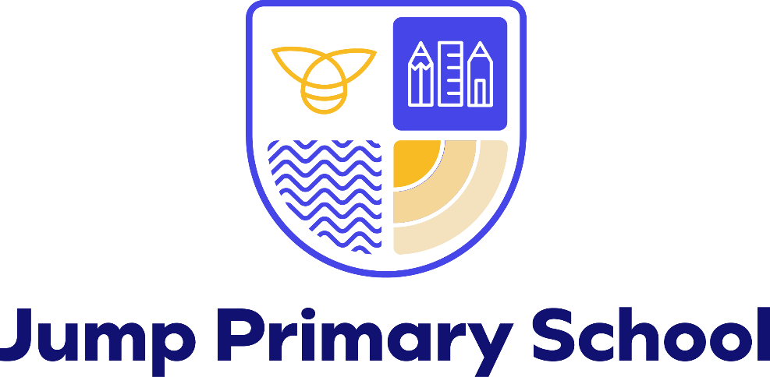

January 2026

Z. Baker
Reading INTENT
‘We aim to develop pupils’ abilities within an integrated programme of Speaking & Listening, Reading & Writing. Pupils will be given opportunities to develop their use, knowledge and understanding of spoken and written English within a broad and balanced curriculum, with opportunities to read for different purposes and consolidate and reinforce taught literacy skills.’


At Jump Primary School, we aim to support all children in becoming confident, fluent and expressive readers who can derive meaning and information from a variety of texts. We also hope to develop a lifelong passion for reading (be confident). We want all pupils to be enthusiastic readers who enjoy showcasing their fluency, vocabulary acquisition, knowledge and skills (be responsible).
From Nursery to Year 6, our aim is to develop pupils who have the stamina and ability to read at least at the age expected standard and who can transfer their English skills to other curriculum subjects (be resilient). We believe that children need to develop a secure knowledge-base in Reading, with oracy underpinning everything we do. Our teachers follow a clear pathway of progression from Early Reading (Read, Write, Inc) to Whole Class Reading sessions in Phase 3. The journey to becoming a proficient reader starts in Nursery. We believe that a secure basis in reading skills is crucial to a high-quality education and will give our children the tools they need to participate fully as a member of society (be self-aware).
We believe that a quality Reading curriculum should also develop children’s love of writing and discussion (be articulate). We aim to inspire an appreciation of our rich and varied literary heritage and a habit of reading widely and often for pleasure, “magpieing” the skills of quality authors. We provide opportunities for reading for purpose and we encourage pupils choose books for themselves. We promote the status of reading by providing opportunities for children’s reading to be celebrated and acknowledged across school.
We encourage our pupils to love books, take care of books and experiment with their reading choice for purpose and for pleasure. We recognise the importance of nurturing a culture where children take pride in their achievements, can read clearly and accurately and with increasing pace and fluency from the Early Years. (be respectful).
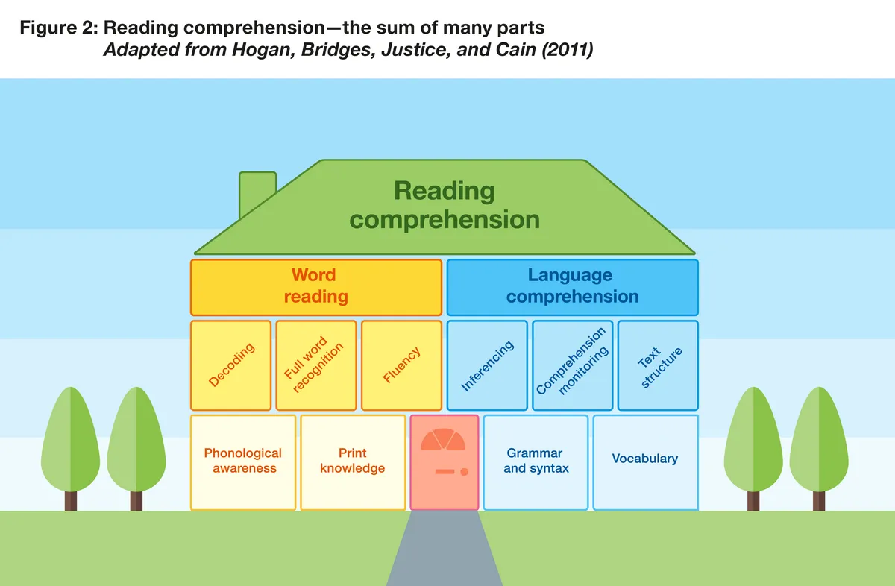

Pupils at Jump Primary School will leave Year 6:
- Reading with confidence, fluency and understanding, using a range of independent strategies to self-monitor and correct.
- With a love or reading and a desire to read for enjoyment.
- With an interest in words and their meanings; developing a growing vocabulary in spoken and written forms
- Understanding a range of text types, media types and genres.
- Using their developing imagination, inventiveness and critical awareness.
- Having a suitable, technical vocabulary to articulate their responses.


Early Reading and Systematic Synthetic Phonics
Early Reading is taught through a multi-skilled approach in accordance with the expectations of the Early Years Framework and National Curriculum. Within Phase 1 (Nursery and Reception), Phase 2 (Year 1, Year 2) and Phase 3 (Year 3, 4, 5 and 6), children are taught phonics using the Read, Write Inc programme. The fidelity of this programme provides our children with the building blocks to decode words. This scheme also supports the reading of sight vocabulary and common exception words. Within these year groups we aim to expand children’s vocabulary through talk throughout the day. Communication and language underpins everything that we do.
Within Nursery a key feature throughout the curriculum is developing auditory discrimination. At Jump, children are provided with a variety of opportunities in which to develop their phonological knowledge from the very start. The focus in Nursery is:
Word Reading- 3-4 years:
Develop their phonological awareness, so that they can: spot and suggest rhymes, count or clap syllables in a word, recognise words with the same initial sound, such as money and mother.
Our expert teachers use Launchpad for Literacy, Jolly Music activities, Anni Mac Tavish rhymes and activities and beat baby activities (where a little toy is passed around the circle whilst the children tap their knees to the beat of the rhymes which they say and contribute ideas to) to establish an early phonological awareness. Music, rhyme and rhythm are also very important at this early stage.

The Early Years Lead has completed a project called ‘Launchpad for Literacy’ which has a pre-RWI focus and provides many detailed activities to support the foundations needed to access RWI during Reception. Segmenting and blending (with Set 1 sounds) skills are taught from late Spring or as children are ready in Nursery. The beginnings of Read, Write, Inc – learning the picture cards, is taught in the Summer term before children enter Reception.

Children in Reception begin to learn Set 1 single letter sounds from Day 1 – we follow Making a Strong Start in Reception with Reception being taught in homogenous groups. RWI is taught through daily discrete phonics sessions and we use a Strong Start tracker to continuously assess. Lessons begin straight away, in the Autumn term with a focus on speed sounds and orally learning to blend. Children are assessed, by the Reading Lead, half termly throughout the year to track progress, with a view that by the Summer term all children are participating in book group reading sessions with green or purple books. Focus sounds are shared with parents to enable children to have the opportunity to share their achievements and reinforce focus sounds.
Across Year 1 and Year 2, there are groups who access phonics teaching at the start of every morning- these begin promptly at 9am. Children also read daily through the use of the ‘Read, Write, Inc book’ in mixed ability pairs within daily phonics lessons with the expectation that children will be reading the grey books by Autumn 2, Year 2. The bottom 20% of children are taught by the expert teachers and all our teachers and support staff are expected to be reading teachers.
Year 3 (and sometimes Year 4, Year 5 and Year 6) also access daily phonics sessions based on RWI if children did not pass the Phonics Screening Check after the second attempt. Children in Year 3 who are SEND or who needed significant support to pass the phonics check, spend the first half term in phonics lessons with a reading teacher, to consolidate the work on sounds before returning to join the class in Autumn 2 to take part in Whole Class Reading sessions. These children are also a focus of the class teacher during daily ‘ERIC’ reading time.
For those children who fail to learn to read early on, extra phonic sessions take place in the afternoons from the very beginning – Pinny Time, Fred Games, 1:1 Tutoring and extra speed sound sessions. Staff and parents are invited to attend regular workshops and are coached by our expert reading lead with support from a Read Write Inc consultant and the online portal.
Individual Reading
Our reading books within school carefully align with the Read Write Inc scheme, in the Early stages of Reading and then are age appropriate for children as they move through our phases. Our phase library areas are constantly being updated with new and exciting books for our children to develop a love of reading, as are our classroom areas.
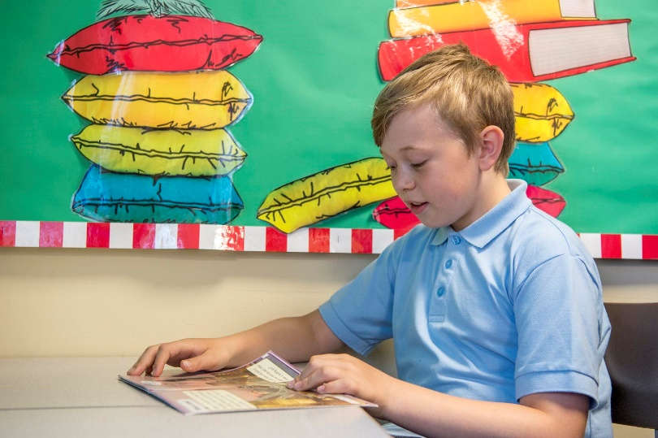

Phase 1 (Nursery and Reception)
Once children enter our Reception class, children begin on their individual reading journey – the magic begins!
Children are also placed by the class teacher on the school phonic reading scheme. School staff listen to the children read daily in school during their phonics lessons once they reach the ‘ditty’ stage and are confident with the first set of sounds. The children are given 2 books to take home and these are changed every 3 days – 1 of these is carefully chosen by school staff and closely matches the phonic sounds that the children are learning in school within their RWI groups. This is the home book bag book. The other book is their RWI book which matches the sounds taught in lessons that week.

A third, optional book, is chosen by the child to extend the breadth of texts that the children are exposed to, it is communicated to parents that children may need support in reading this book.
Comments are recorded in individual reading records by parents (self-corrections / miscues / word meanings/targets achieved / next steps for learning) and this is then communicated to teachers through the home school reading record.
As children move through Year 1 and Year 2, reading, on a daily basis, continues in the same way.

Phase 2 (Year 1 and 2)

Within Phase 2, children are listened to read, in Read Write Inc sessions, according to each child’s individual need. The lowest 20% readers in each class are listened to read multiple times over the week by one of our reading experts. When they are ready, these children have access to specific reading interventions (Nessy).
From Year 2, children are allocated time to read for pleasure and are encouraged to do so. This allows the teacher and classroom support to listen to children read and initiate talk about books. By the end of Key Stage 1, our aim is for all children to be fluent readers. Children are encouraged to choose books from their phase library area which closely matches their reading ability and reading age.

Phase 3 (Year 3, 4, 5 and 6)

As children move into Phase 3 they continue to be listened to read during whole class read time. The emphasis moves from developing fluency to developing deeper comprehension strategies. As children and staff feel they are ready to progress, they move to a free reader library. These books have been carefully chosen to provide breadth and challenge, including well known authors as well as some lesser known authors. This library contains many books that are brand new releases with an intention to inspire their love of reading. The school staff emphasis moves from listening to children read these books and towards discussion about books and reading choices; guiding children towards texts that may inspire, challenge or support children as needed.

Reading for Pleasure
Phase 1
The children have access to well resourced reading areas and high quality, diverse texts within all areas of the environment to enjoy within their play, either independently, with peers, or with an adult.
They have a daily storytime (Scribble Club / Drawing Club) at the end of each day with ‘repeated read’ texts chosen either by the children or an adult. When possible, children are also read to in small groups.
All children within Phase 1 can choose a book from the class library to take home and share with parents to support the development of a love of reading, wider knowledge and interests.
Children can access playtime reading suitcases to read with peers or independently for pleasure during playtimes and lunchtimes. Repeated reads are encouraged in order to promote vocabulary, speech and language acquisition.
Phase 2 and 3
Through our book talk and book clubs, we encourage children to read books independently either from class libraries or their home reading book. Class teachers use this time to listen to specific children read and to promote book talk.
At the end of the day all classes have a daily storytime where a class book is read for pleasure by the class teacher or CSA. The joy of reading books is modelled using a text which is pitched at a higher level than that of the cohort’s reading ability. This also helps to develop vocabulary which is displayed. These texts form part of each classes ‘Reading Journey.’ At least once a week, our classes also participate in a Book Club where books are shared and recommended to each other.
Whole Class Reading (takes place daily) texts for comprehension sessions are also chosen carefully in order to inspire a love and pleasure in reading using Fred Teaches Reading materials. We aim to cover a range of reading domains within these sessions, alongside developing children’s vocabulary, communication and language and widening their cultural capital.
Children can access playtime reading suitcases to read with peers or independently for pleasure during playtimes and lunchtimes.
Each class has a ‘Reading Scrapbook’ which is taken home by a different child each week – children are encouraged to recommend books to each other and share their love of reading.
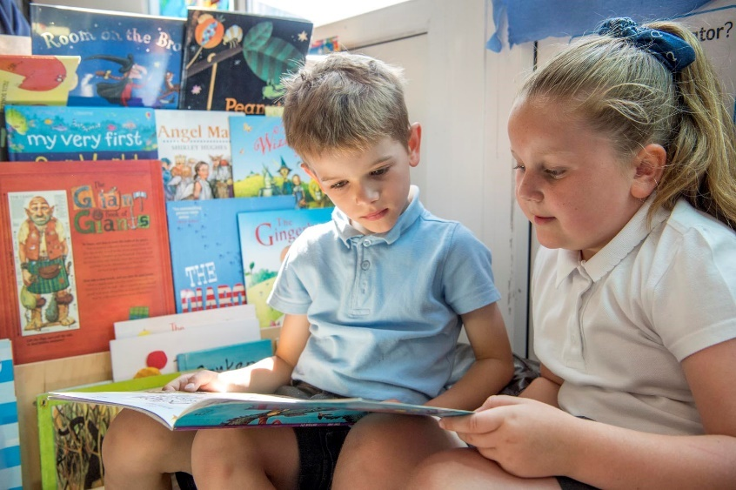

Quality first reading provision in English lessons
Phase 1
Children participate in daily, whole class English lessons (Magic of Stories for Nursery). These sessions focus on developing a deep knowledge of the book that they are studying and thematic work supports schema building around this. The English lessons provide an opportunity to introduce and develop children’s knowledge and understanding of a breadth of vocabulary and language. The displays are used to identify and celebrate ‘wow’ words. Children are encouraged to innovate and recreate texts and reading genres within their writing.
Follow up work supports children to draw on newly learnt knowledge to deepen their understanding and to practise important writing/pre-writing skills.
All Phase 1 staff are ELKLAN trained in considering how to make the environment a communication friendly setting, recognising the crucial link between developing and supporting Oracy and literacy skills and quickly identifying children who may require additional support with this. Back and forth conversations are encouraged at every opportunity in order to develop and extend children’s language. Careful and deliberate planning provides these opportunities.
Phase 2 and 3
Word rich environments support reading and children are encouraged to magpie new words and vocabulary at every opportunity. Teachers embed reading within English Writing and Whole Class Reading lessons, focussing on developing an understanding of word meanings and comprehension skills from Year 2 upwards. These sessions support children to define new and ambitious vocabulary, develop their ability to infer and deduce, understand the structure of different text types and gain an understanding of the author’s intent.
Teachers ensure that over the year, a variety of fiction, non-fiction and poetry are taught.

Whole Class Reading – From Fluency to Comprehension
Training was undertaken by all class teachers and CSA’s in the Autumn term 2020. This was then revisited with a writing lens in Spring 2022. September 2025 will also build on this training in both Reading and Writing.
Phase 1
Within Phase 1 teachers use the WCR approaches within their daily English lessons and as part of Drawing Club. Pre-experiences are given before new books are introduced to help children to build a strong schema around the text that they are studying. Tricky or ambitious vocabulary within the text is also discussed and echoed before the text is read. Class teachers carefully choose parts of the texts to focus in on to develop children’s skills within word reading, comprehension and knowledge of text types further. A variety of alternative, linked texts are introduced either alongside the text being studied or afterwards to continue to build secure schema and a deep knowledge.
Phase 2 and Phase 3
During the Autumn term, Year 2 continue to use phonic books and integrate WCR approaches into daily English lessons.
Fluency is taught with fidelity, as per training delivered by the English Hub. This happens on a Monday and then strategies are built in to the subsequent lessons. Children who struggle to develop their fluency access an intervention which follows the same structure, three times a week.
Within Year 2 to Year 6 children take part in WCR lessons daily which last 45 mins each (Children in Year 2 who still access RWI have a separate WCR session). The texts for these lessons are selected to be ambitious and just beyond the independent reading level of the class. The WCR lessons help children to hear and develop fluency, increase the breadth and understanding of ambitious vocabulary, develop deeper comprehension skills, enjoy texts which may be too challenging to tackle independently and ensures that all children feel successful within their own reading abilities and skills.
Reading across the curriculum
Reading is planned within other subjects to develop enquiry and research skills as much as possible. The Reading Leader monitors planning, checking that this is happening. Reading is encouraged throughout all sessions and comprehension applied in context. E.g reading and understanding Maths questions.
Progression in reading
The reading leader has produced a detailed document highlighting the key knowledge and reading skills taught from Nursery to Year 6 in the areas of: Familiarity with texts, Word reading and Comprehension. She has also produced a document highlighting the key texts looked at in each year group from Nursery to Year 6.

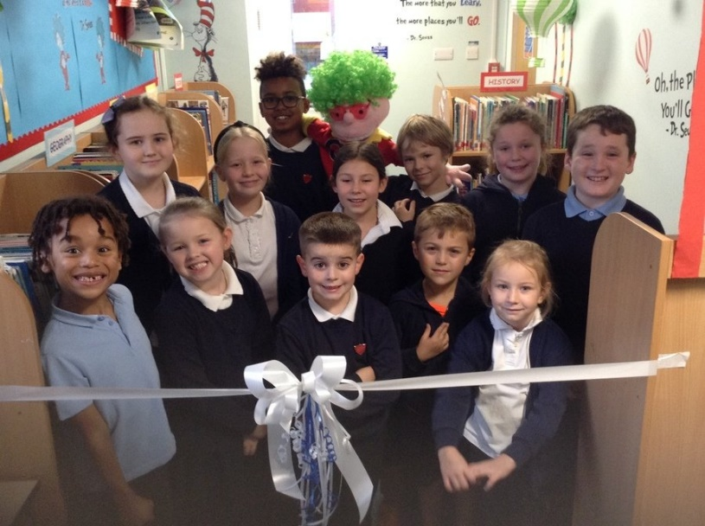

Storytime
We believe that literature is the most powerful medium through which children have a chance to raise their ambitions and aspirations. Through story times (which take place in each class, at the end of each day) and book clubs, children are able to use their imagination and learn about the lives and perspectives of those who have lives different to theirs. We aim to choose the right books in order that our children can thrive, whatever their background. These sessions aim to promote a love of reading and share with our children their teacher as a reader. We have a core set of stories (Reading Spine) which we hope elicit a strong response from our children.
Our younger children have stories repeatedly read to them so that familiarity deepens and there are opportunities built in to explore language, characters, feelings and emotions. Children are encouraged to join in with parts of stories and re-read it for themselves.

Quality and use of assessment information to inform planned provision
EYFS
Children in EYFS are baselined on entry (FS1 and/or FS2) then termly to the end of EYFS to evidence progress across each class and across EYFS as a whole. EYFS assessment is ongoing through high quality observations and interactions on a daily basis referenced against the revised EYFS statutory framework. Data is analysed termly usually by the Phase 1 leader and from this a percentage is calculated for children on track to meet ELG and GLD by the end of EYFS. Information is shared with all EYFS staff and SLT. Relevant information is shared by the Headteacher with Governors.
In addition to this, children complete a RWI phonic assessment on entry and then half termly throughout the year. This is used to organise children into appropriate teaching groups.
Gaps trackers are used to inform planning which is themed around children’s interests. EYFS was moderated and an audit undertaken by LA in 2017. There were no issues with provision, environment or resources.
Year 1
Within Year 1 children begin to use NFER tests from the Spring term, when they are fluent readers, to provide a standardised score to support the monitoring of attainment and progress. These tests are used to give an insight into the gaps in children’s knowledge and to allow teachers to plan appropriate lessons to support children in their understanding. A fluency rubric is also used to identify the small steps needed to increase fluency, pace and automaticity.
At the end of Year 1 children undertake the statutory Phonics screening check. A practice check takes place in Spring 1 which supports the Year 1 teacher in putting in place interventions for the next 2 terms. Practise activities are also sent home for homework and used as starters to English lessons.
Teachers use their knowledge of individuals based on responses in reading sessions, phonics and other subjects, 1-1 reading sessions, test scores to form an overall teacher judgement at the end of each term, this is reported in Insight and the Reading leader moderates the correlation of this. Class teachers use this information to plan next steps for each individual child (ie. Moving book bands, changing groups, addressing gaps, etc). PPM identify children who are not making progress or who are showing slowed progress and actions planned in appropriately (Intervention put in place / extra reads / etc). There are clear expectations about where children should be on a term by term basis, enabling the bottom 20% to catch up.
Year 2 Onwards
Children undertake a termly NFER test which provides a standardised score to support the monitoring of attainment and progress. These tests give an insight into the gaps in children’s knowledge and allow teachers to plan appropriately challenging lessons that support children in their understanding.
Within Year 6 practise SAT papers are used in Autumn 1 and Spring 1 and the statutory SAT tests are carried out in May.
Teachers use their knowledge of individuals based on responses in reading sessions and other subjects, 1-1 reading sessions, test scores to form an overall teacher judgement at the end of each term, this is reported in Insight and the Reading leader moderates the correlation of this. Class teachers use this information to plan next steps for each individual child (ie. Moving book bands, changing groups, addressing gaps, etc). PPM identify children who are not making progress or who are showing slowed progress and actions planned in appropriately (Intervention put in place / extra reads / etc). There are clear expectations about where children should be on a term by term basis, enabling the bottom 20% to catch up.
Fluency Rubrics are also used to determine the small steps required for children to develop a sense of pace and automaticity. These are completed half termly in Year 1 and Year 2 and then continued to be used with the bottom 20% readers from Year 3 onwards.

Sharing information with parents
Phase 1
Information is shared with parents via EazMag in EYFS and through class noticeboards and floor books.
Parents are also invited into school for additional reading events and celebrations linked to our stories e.g. Alien tea party, bear hunt walks etc
Phase 2
Year 1 and Year 2 run regular phonics parents workshop each year to allow parents to understand the Year 1 phonic check and to give the opportunity to ask questions.
Phase 3
KS2 SAT’s meeting takes place every year to allow parents to ask questions and understand the content of the assessments.
For all classes, newsletters are sent home half termly giving parents ideas for activities at home linked to the learning in school. 3 parent evenings a year are carried out, an annual report and an open-door policy allows parents a range of opportunities to discuss their child’s progress in school. School Comms shares assessment information with parents every term (Y1 – 6).
Facebook is used to keep parents updated with any reading initiatives and messages within school.
Interventions
Children with specific needs have been identified and screened by the SENCO using Nessy. Children are then given access to the program 20 minutes daily.
Children who are working within the bottom 20% of the class for reading are identified and tracked closely each term by the reading leader. These children have additional interventions and individual plans in place to enable them to catch up quickly and close the gap.
Pupils on the SEND register for Reading are supported with a daily reading intervention from year 2 onwards.
PPM meetings held each term by Phase leaders with class teachers identify children within reading who class teachers have concerns about (this is not just the bottom 20%), action is planned for these children
Fluency interventions run 3 x per week for children in Year 3 and Year 4.
WCR sessions run 3 times per week for those children in Year 2 who still access RWI in the Spring term.

Whole school
- Classes identify their ‘Top 5’ in the first week of the academic year. These are displayed on classroom doors. Children are encouraged to recommend books to others.
- Book fairs take place at least annually
- Ready steady read sponsored event takes place every year to raise money to buy new, up to date books for class libraries
- World book day is celebrated each year.
- World read aloud day is celebrated each year and a reading bingo is initiated for the month.
- Reading leader monitors planning and moderates sample children to check they are on the correct reading book. Information gained is fed back to individual staff or at a staff meeting if needed.
- Class libraries audited and vision set out to staff June 2021.Further audit took place in June 2022 after reading leader attended training with the English Hub.
- Class paired reading takes place on themed days where older children read to younger children.
- Poet visit 2018, Author visit (Malcolm Hogan) 2019, Virtual author visit Tom Palmer 2021 (Y2-6), Jen Carney virtual visit Y4 2021, David O’ Doherty virtual visit Y5 and Y6 2021. Virtual Poet Workshop for KS2 (Ian Bland) – Autumn 2 2023, Poet Visit – Joseph Bower (Remembrance Day 2023)
- Playtime reading suitcases set up – June 2021
- Photos and posts on Facebook to raise awareness of reading in school
- Reading survey of Reception to Year 6 undertaken Summer 2021 and repeated annually.
- Pupil voice following Tom Palmer virtual visit – purchase of books for hampers for Phase 2 / 3
- Reading scheme ORT 16+ - library pod created for free reader books
- BEFT project undertaken in EYFS 2019 – 2021 Hooked on a book; 2018-19 Sing a song, tell a tale.
- ELKLAN training undertaken by all phase 1 staff 2021-2022 and the achievement of communication friendly status. The SENDCo and EYFS teacher is the ELKLAN lead.
- Numerous training opportunities offered to Teachers and CSA’s throughout the year.
- Whole school home reading challenge introduced September 2019 to encourage reading at home
- Book Talk areas set up in social spaces.
- Visits to other schools took place in Summer 2022 by EYFS staff and reading leader.
- Teacher introduces themselves as a reader to children in the Autumn term – children complete ‘I am a Reader’ document half termly.
- Year 5 / 6 have individual scrapbooks to complete after each read.
- Autumn 2023 – Reading Buddy system set up.
- School librarians share a vital role in promoting book talk across school.
Previous Reading Deep Dives
A reading deep dive was undertaken by Linda Singleton (SEO) on 2nd December 2019. The purpose of this visit was to; ‘Evaluate the extent to which leaders have embedded a coherently planned and sequenced broad and balanced curriculum that is ambitious and meets the needs of all learners, particularly the most disadvantaged and those with SEND, to ensure they acquire the knowledge and skills they need to be successful.’
During the visit LS spoke with the Reading and Phonics Leaders, visited reading and phonics lessons, listened to children read, spoke to a wide variety of staff within school, spoke with children, spoke to a number of parents and looked at a sample of children’s work.
The Deep Dive had many positive outcomes and targets given have been developed upon since 2019.
Peer Review – 3.3.23
Phonics
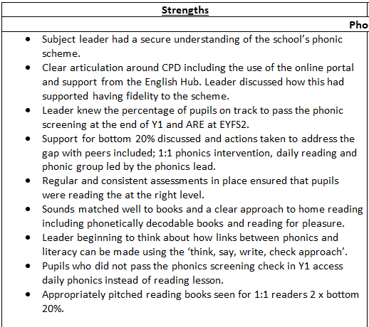
Reading for Pleasure and Whole Class Reading
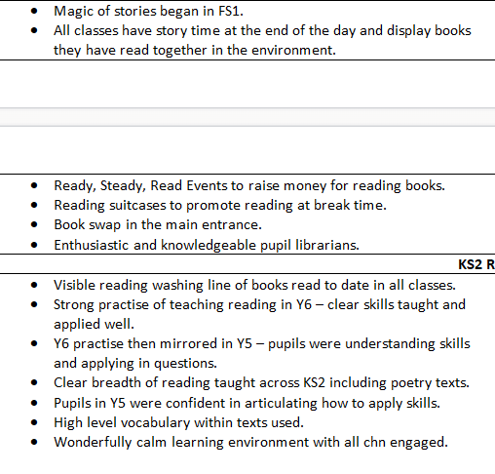
English Audit by the English Hub – 18th January 2023
Good afternoon, thank you so much for your time last week when I came out for the EH audit. It was lovely to see how invested you are with RWI and the early reading and phonics.
All children are taught by expert reading teachers. Our teachers and support staff have worked at school for a number of years and have recently attended training. They all have access to the RWI portal.
From our drop ins to sessions the following was clear:
Consistency in resources in all teaching spaces
Children were confident with the structure of the lessons and were enthusiastic with their learning
Class management was good and sessions were very efficient with no time wasted in extra teacher talk.
Explanation of words and vocabulary development was done without loss of pace
Steps to teaching spelling were solid and consistent across groups
Clear strategies for reading and spelling were being taught and were obvious to children in lessons
Lessons were pacey and staff appeared confident with their teaching.
Reception children second group is a focus for coaching
NB: See Audit Report for full details.
Further Evidence
- Reading correlation through Insight
- Reading leader produces termly data pack showing attainment, progress, impact through school
- Individual reading records
- Baseline data from EYFS
- Phonics screening check in Year 1 and repeat in Year 2
- WCSR planning
- English planning
- Samples of children’s work
- SEO Reading Deep Dive report Dec 2019
- Whole Class Reading Comprehension books.
- Pupil Voice surveys.
- Parent Surveys.
- ‘I am a Reader’ – attitudes to Reading Evidence

